Project Design Phase-II
Data Flow Diagram & User Stories

Date | 04-07-2026
Team ID
Project Name | SB Stocks - Stock Trading Application (MERN)
Maximum Marks | 4 Marks

Data Flow Diagrams:
A Data Flow Diagram (DFD) is a traditional visual representation of the information flows within a system. A neat and clear DFD can depict the right amount of the system requirement graphically. It shows how data enters and leaves the system, what changes the information, and where data is stored.

Example: (Simplified)



SB Stocks – Data Flow Diagrams
Level 0 (Context Diagram): shows SB Stocks as a single process exchanging data with the Trader, Admin, and the external Stock Market Data Provider.
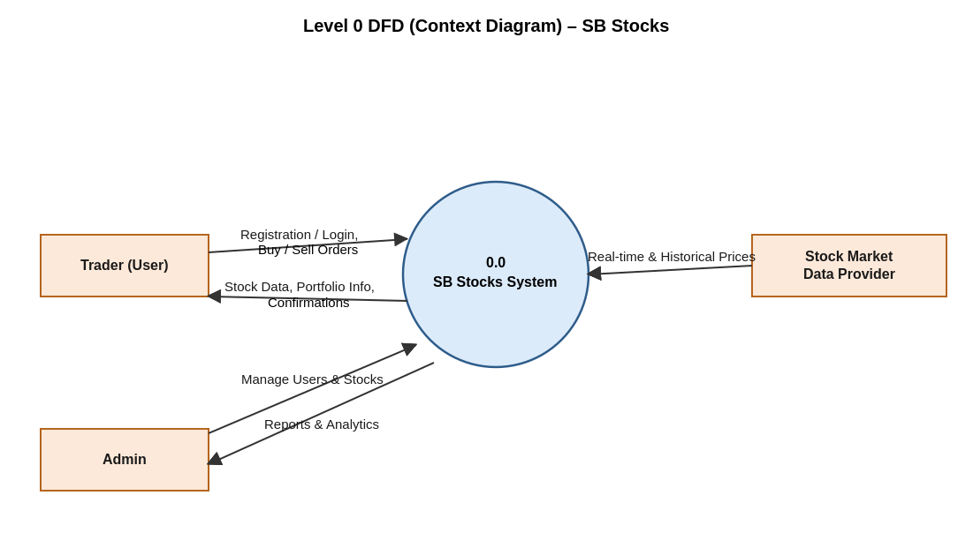
Level 1 DFD: breaks the system into five core processes – User Registration & Login, Stock Data Management, Order Processing (Buy/Sell), Portfolio & Transaction Tracking, and Admin Management – along with the Users, Stocks, Orders, and Transactions data stores.
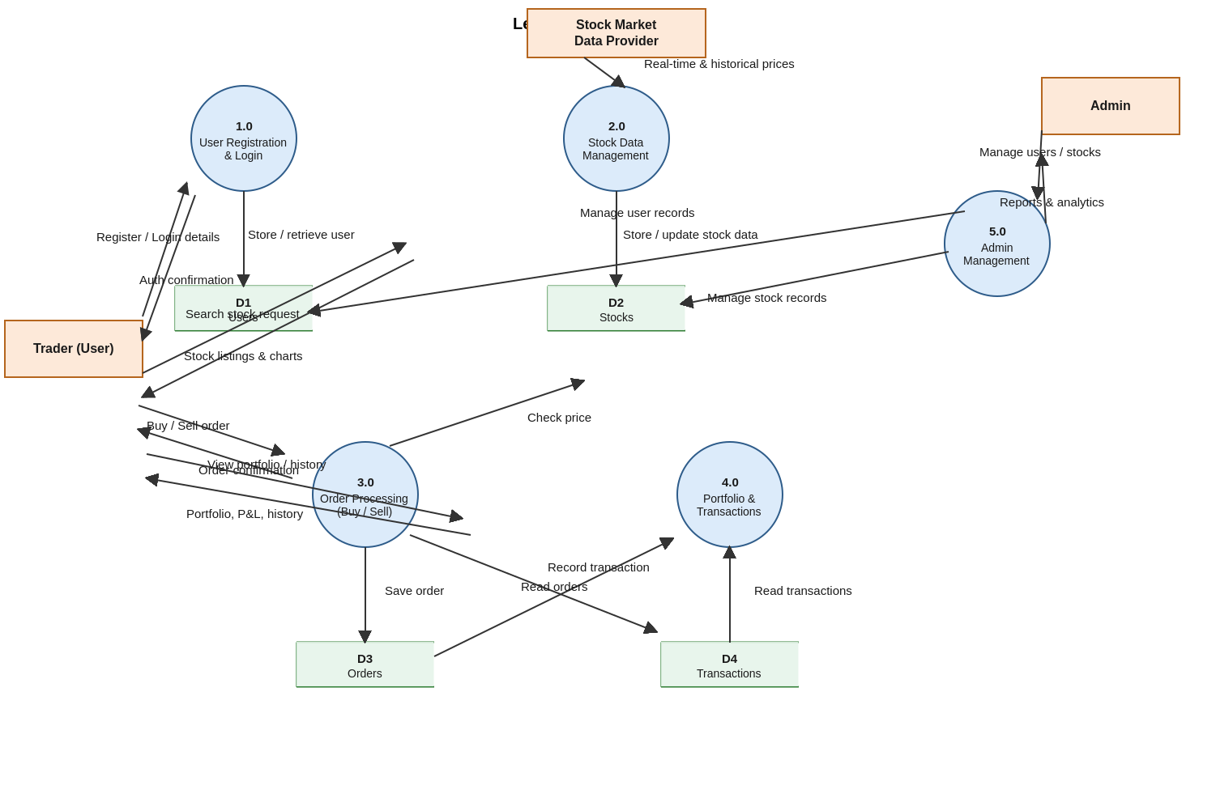

User Stories
Use the below template to list all the user stories for the product.
User Type | Functional Requirement (Epic) | User Story Number | User Story / Task | Acceptance Criteria | Priority | Release
User (Trader) | Registration | USN-1 | As a user, I can register for the application by entering my name, email, and password. | I can access my account/dashboard after registering | High | Sprint-1
User (Trader) | Registration | USN-2 | As a user, I will receive a confirmation email once I have registered for the application. | I receive a confirmation email and can access my account | High | Sprint-1
User (Trader) | Login | USN-3 | As a user, I can log into the application by entering my registered email and password. | I can log in and land on my personalized dashboard | High | Sprint-1
User (Trader) | Login | USN-4 | As a user, I want to stay securely logged in so I don't have to log in every time I visit. | My session remains active until I log out | Medium | Sprint-2
User (Trader) | Dashboard | USN-5 | As a user, I can view my virtual balance, portfolio summary, and recent activity on my dashboard. | I can see my balance, holdings, and recent trades at a glance | High | Sprint-1
User (Trader) | Stock Listings | USN-6 | As a user, I can browse and search stock listings by name, category, or sector. | I can find stocks matching my search or filter criteria | High | Sprint-2
User (Trader) | Stock Listings | USN-7 | As a user, I can view the real-time price and historical chart for a selected stock. | I can see the current price and a historical price chart for any stock | High | Sprint-2
User (Trader) | Trading (Buy/Sell) | USN-8 | As a user, I can buy a stock by entering the quantity and confirming the order. | My virtual balance and portfolio update immediately after the buy order | High | Sprint-3
User (Trader) | Trading (Buy/Sell) | USN-9 | As a user, I can sell a stock I own by entering the quantity and confirming the order. | My virtual balance and portfolio update immediately after the sell order | High | Sprint-3
User (Trader) | Portfolio Management | USN-10 | As a user, I can view my current holdings, profit/loss, and overall portfolio performance. | I can see accurate profit/loss and performance metrics for my portfolio | High | Sprint-3
User (Trader) | Portfolio Management | USN-11 | As a user, I can view a history of all my past buy/sell transactions. | I can see a complete, timestamped log of my trading activity | Medium | Sprint-3
Administrator | Admin Authentication | USN-12 | As an admin, I can securely log in to a separate admin dashboard. | I can access admin features only after a valid admin login | High | Sprint-2
Administrator | User Management | USN-13 | As an admin, I can view and manage all registered users on the platform. | I can see a list of users and take action (e.g. disable an account) | Medium | Sprint-4
Administrator | Stock & Order Management | USN-14 | As an admin, I can view all stock orders placed across the platform. | I can see a complete list of orders with user and stock details | High | Sprint-4
Administrator | Transaction Monitoring | USN-15 | As an admin, I can view all transactions across the platform to monitor activity. | I can see a complete, filterable log of all transactions | Medium | Sprint-4

